**Question 3:**

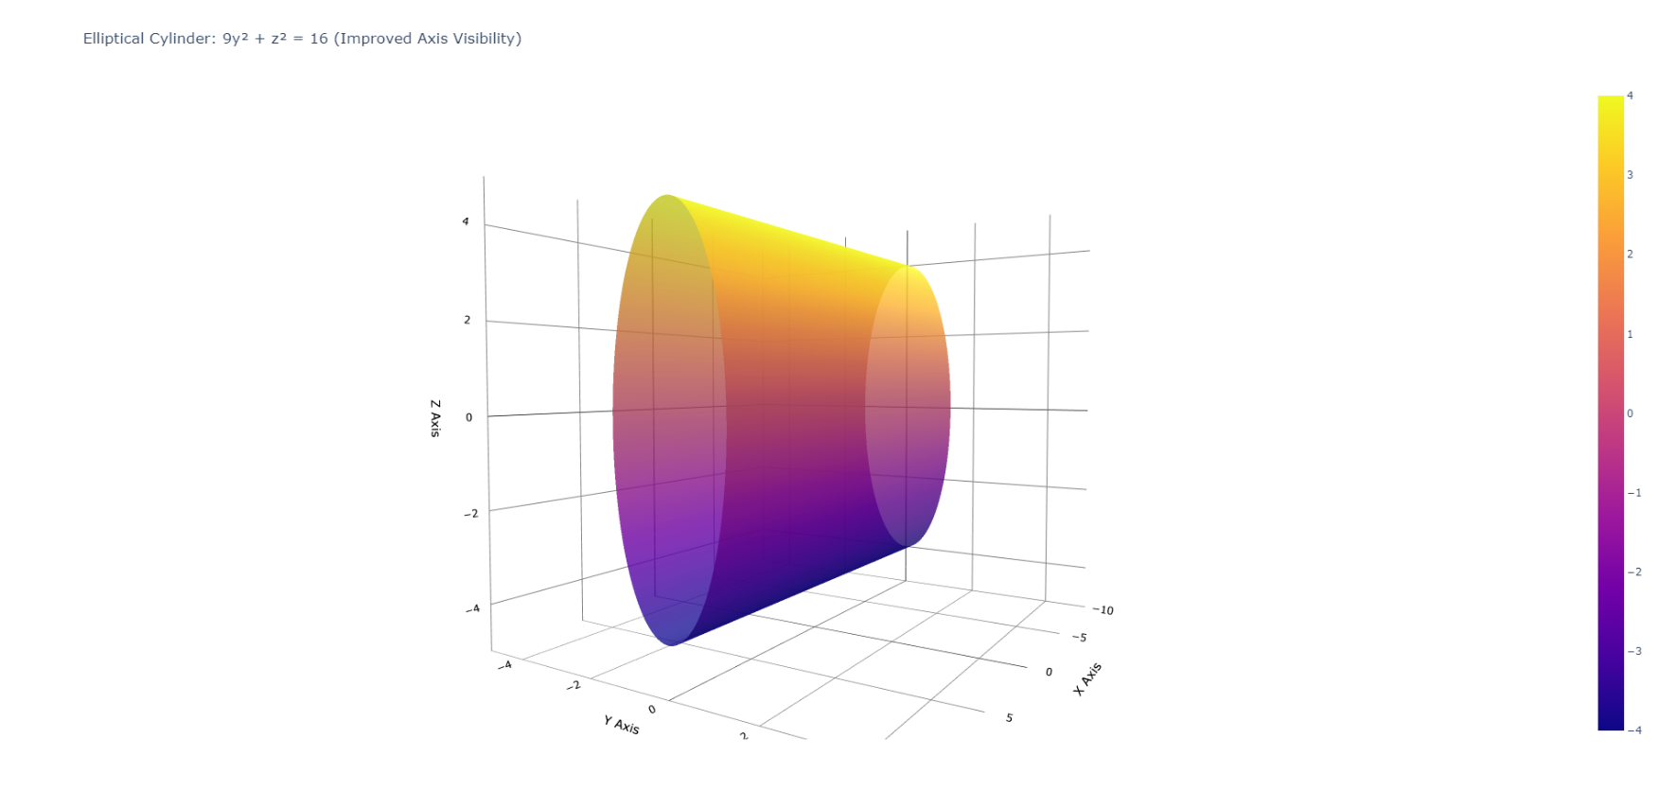

**Question 20:**

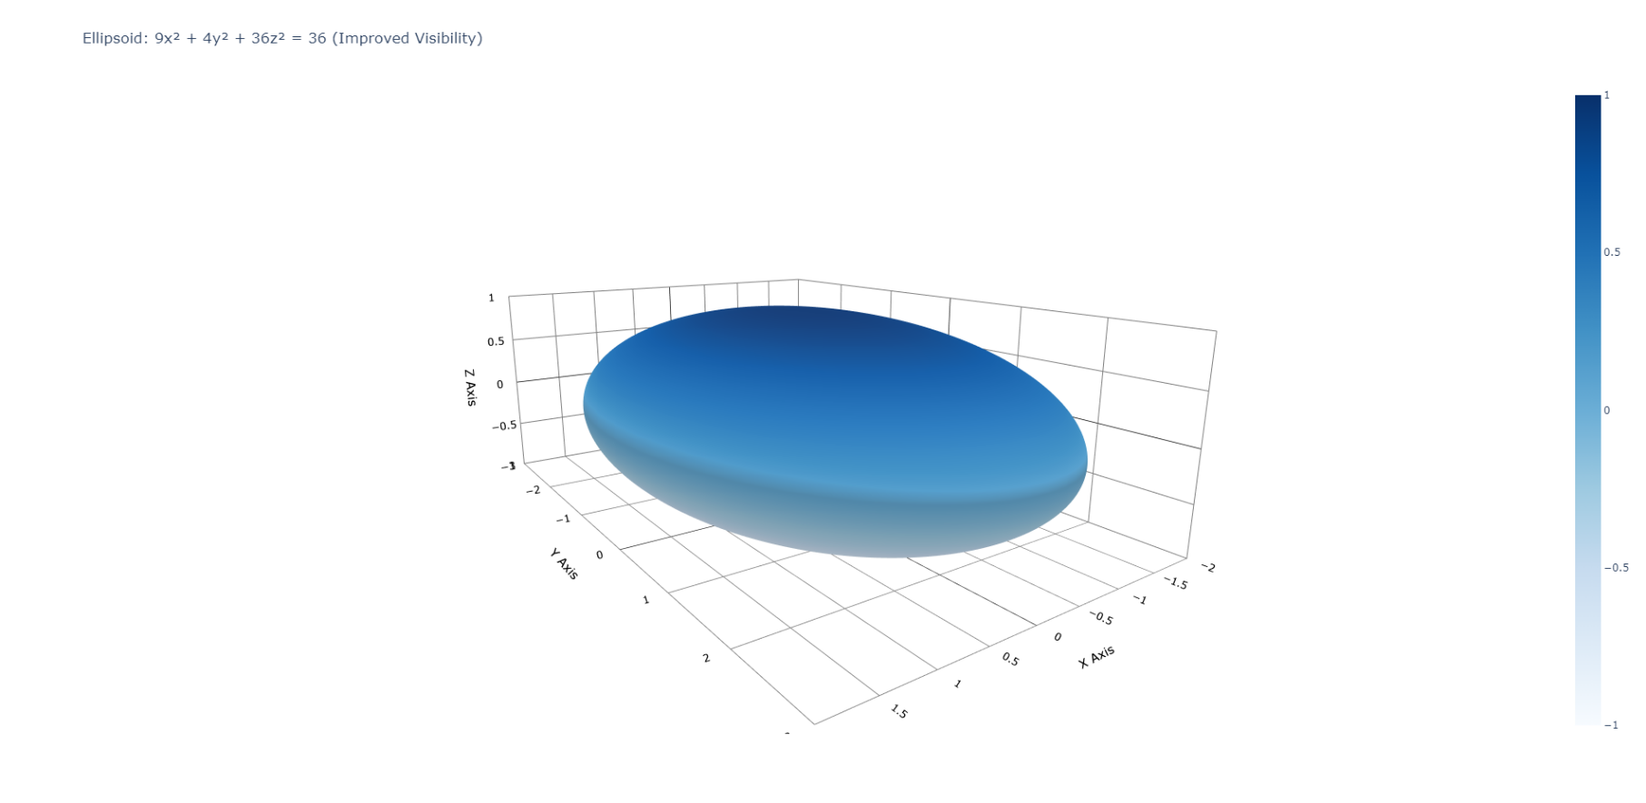

**Question 23:**

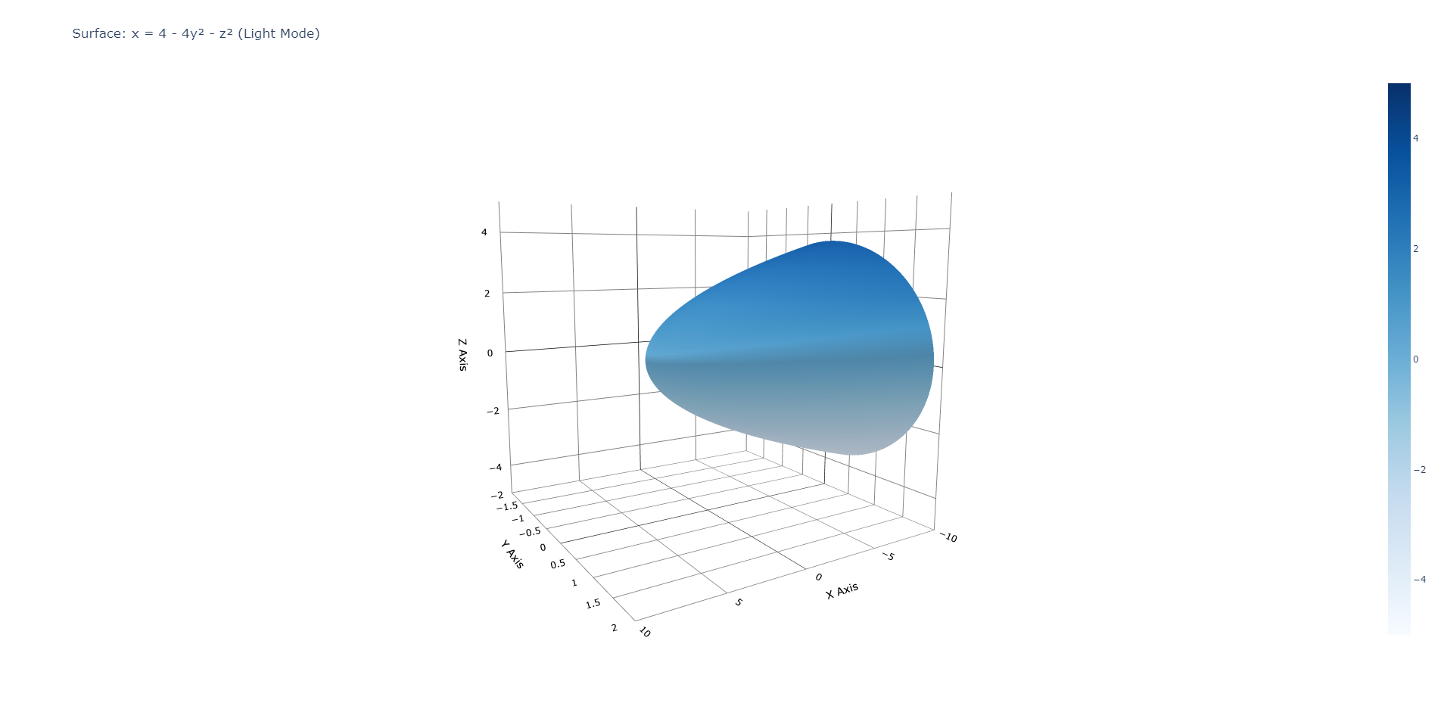

**Question 27:**

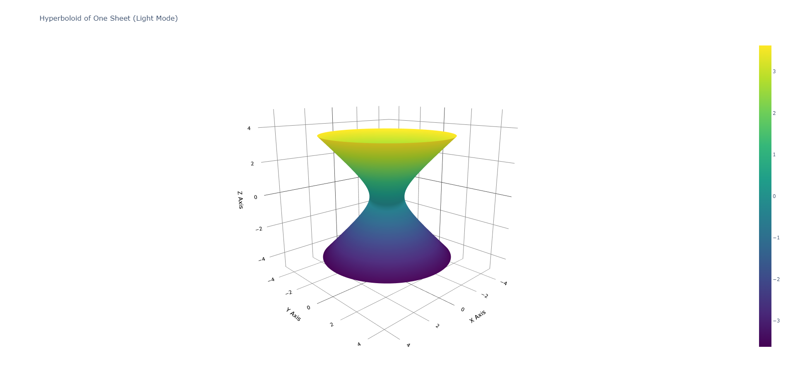

**Question 49:**

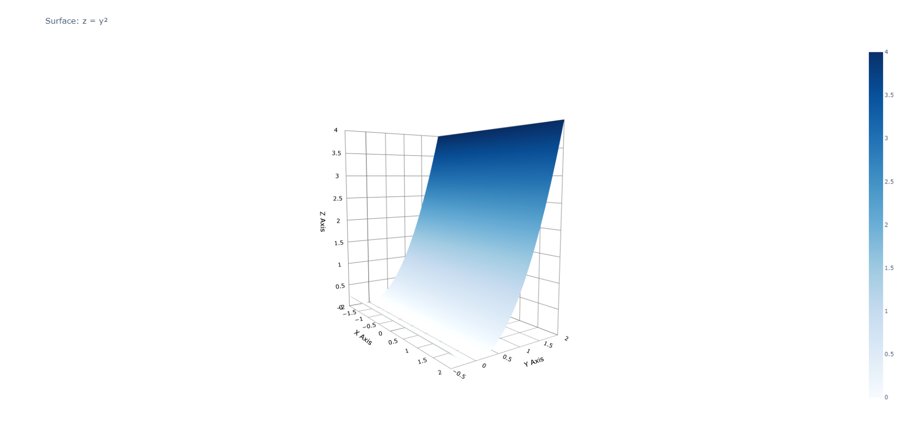

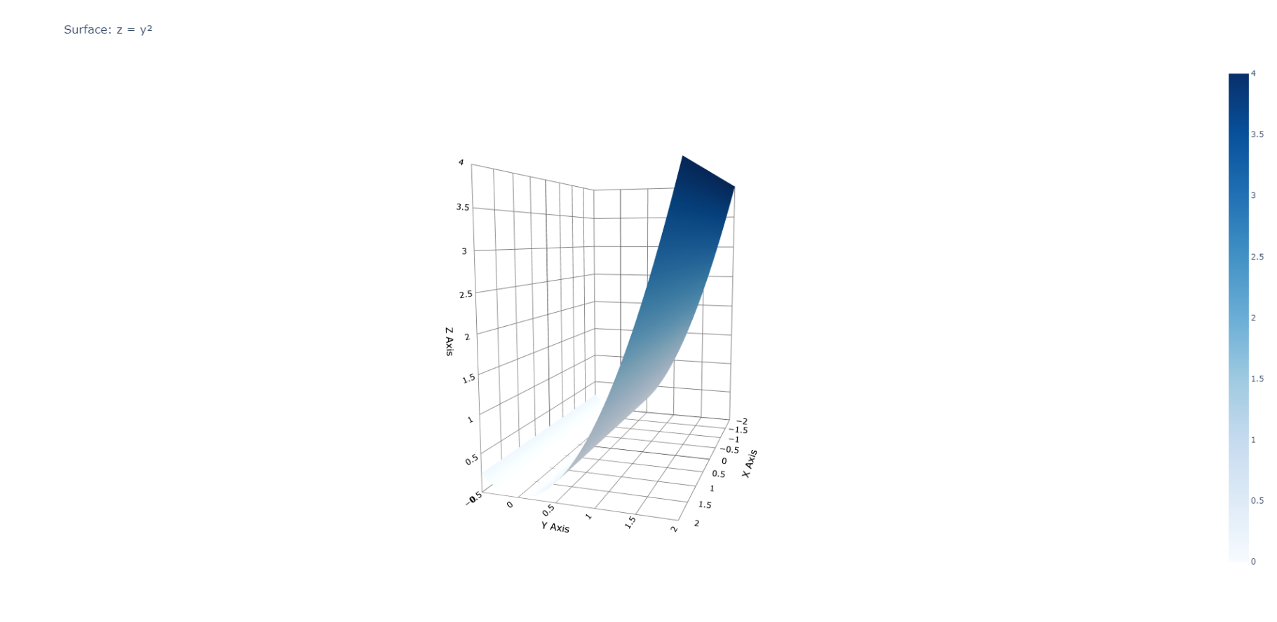

**Question 50:**

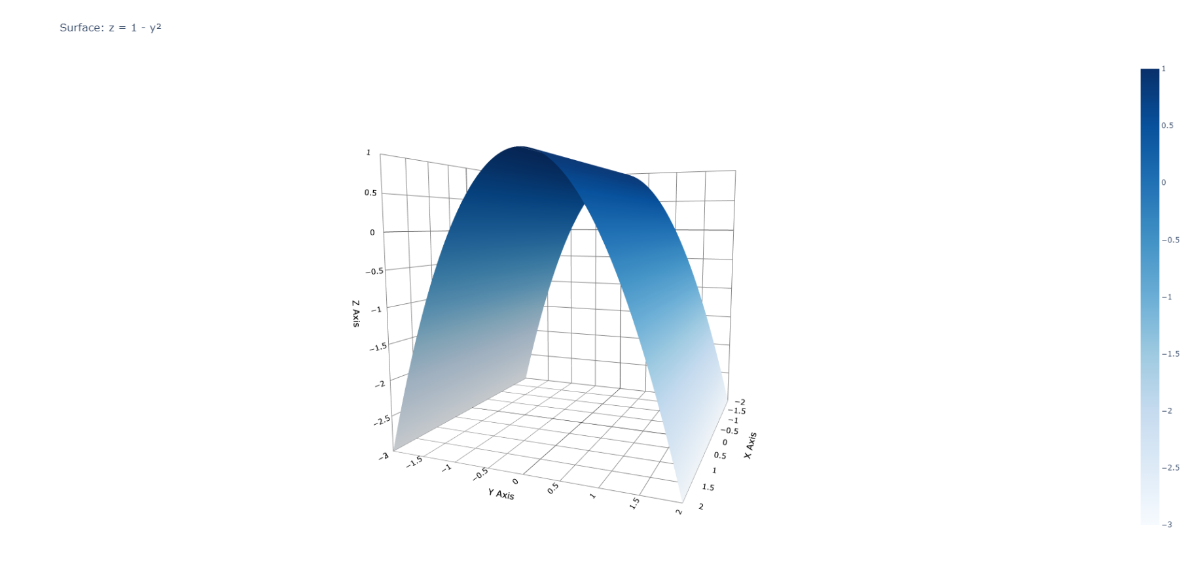

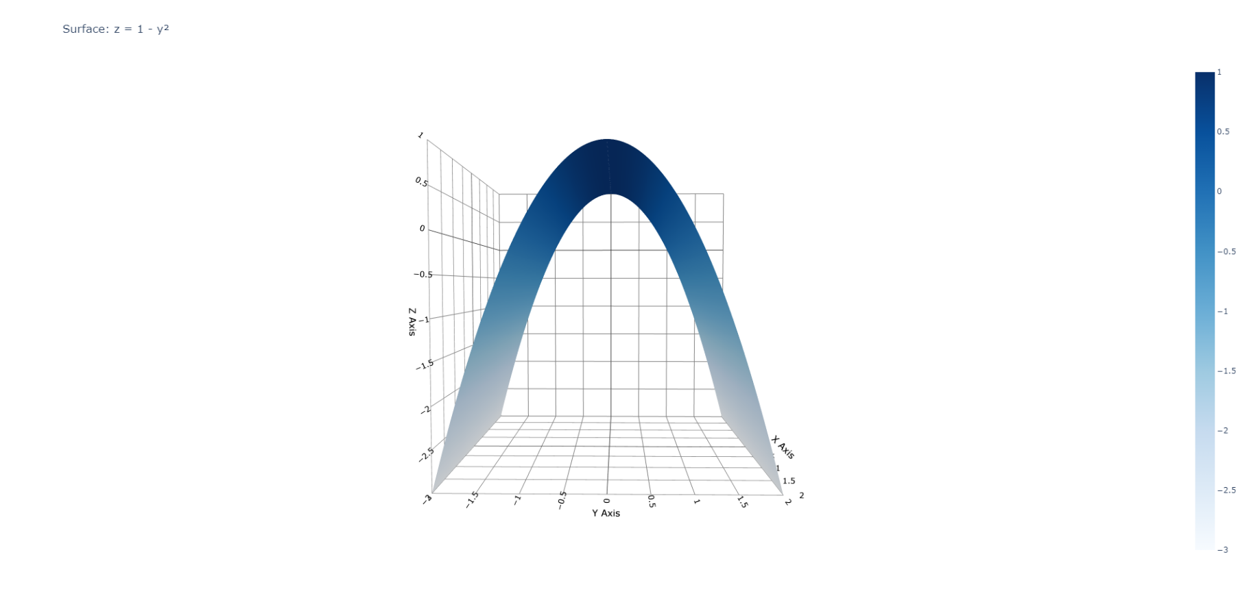

**Question 51:**

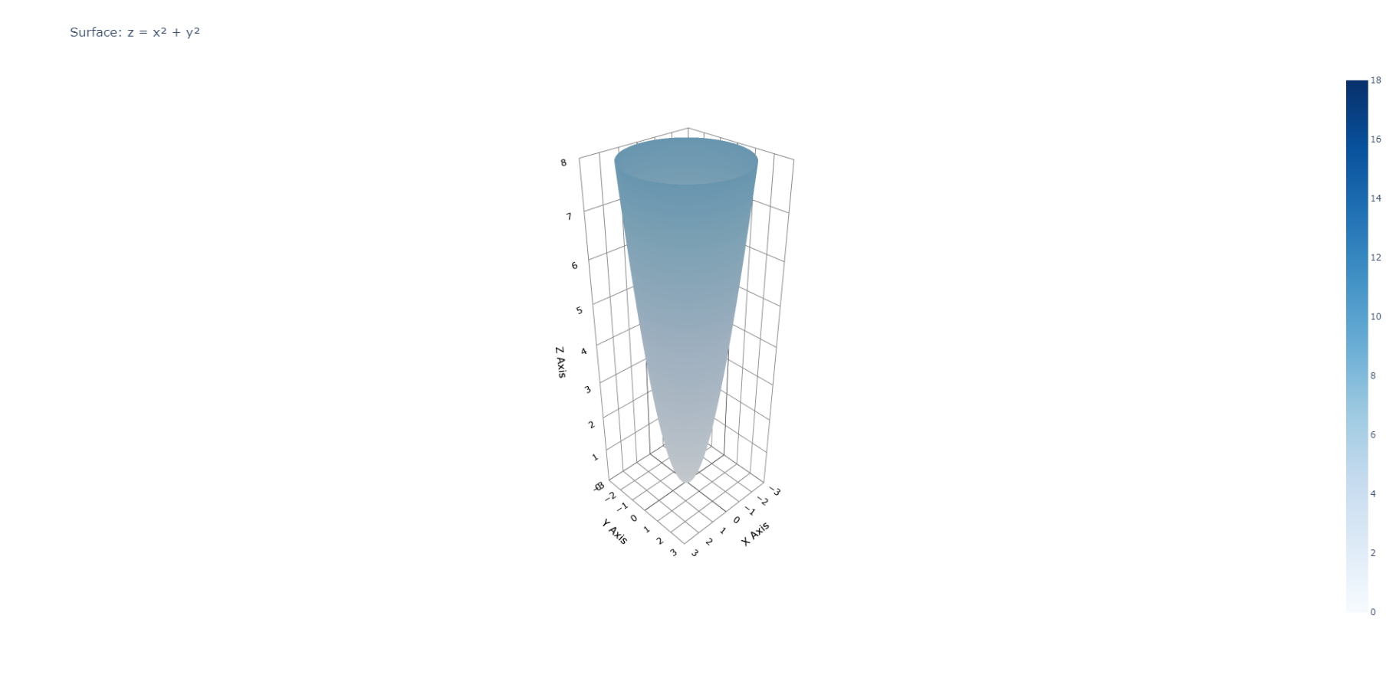

**Question 52:**

**a)**

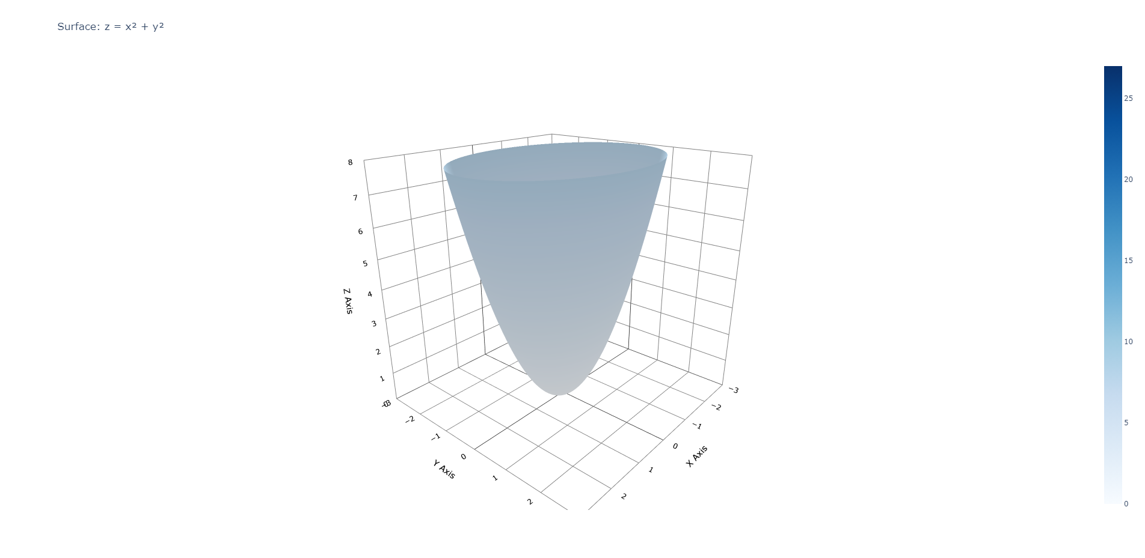

**b)**

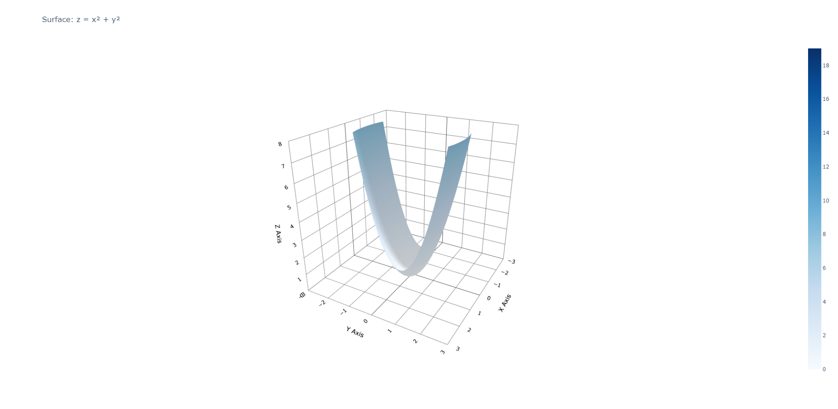

**c)**

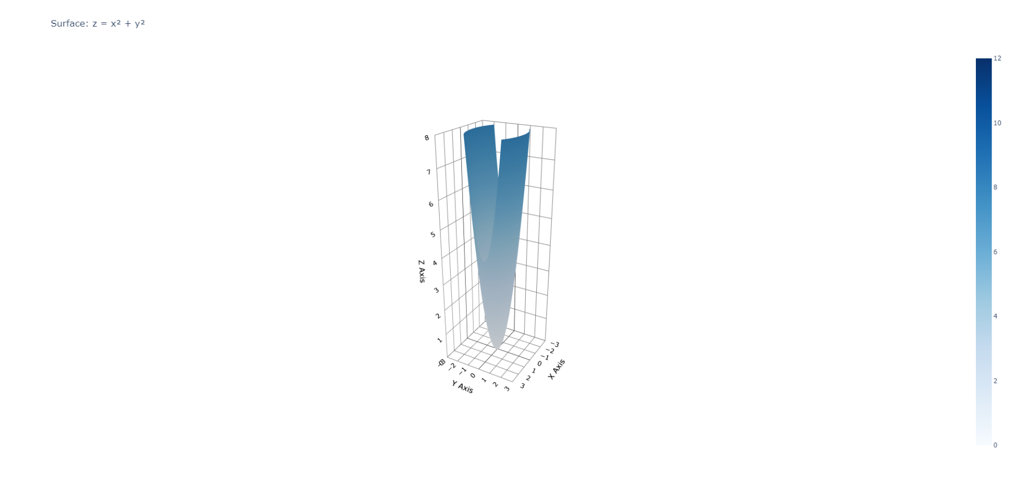

**d)**

**Code:**

**Libraries:**

**Ellipsoid (parameters + plot):**

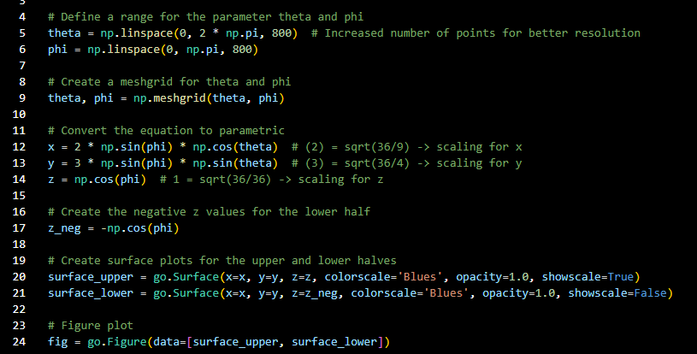

**Hyperboloid (parameters + plot):**

**Paraboloid (parameters + plot):**

**Printing + Formatting:**

Background colour, limits, line colour, grid colour, have been changed for better visibility